WALHALLEN EUROPADETEKTIV – DETEKTIVBYRÅ

PRIVATE COMMERCIAL – BUSINESS DETECTIVES

CRIME SCENE lV-11. THE PERFECT DAWN.

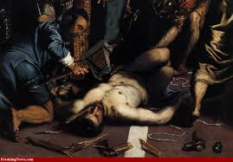A recent crime.

INTRODUCTION: Are we seeing The Perfect Dawn around the globe, economically, politically and environmentally – or something else? One man’s Utopia is another’s Dystopia, and real jobs are being lost, temporarily or permanently, in a great shift eastwards. We all want to be independent, which many view as suspect in essence, and still we are all part of a cluster or tribal culture that so dominates our daily life. Media broadcast a view about an imaginary truth, a truth that even Sigmund Freud depicted as fluid, and ethics that everyone adheres to, or not; an ethics, individual or tribal, that is supposed to have influenced our lives since Cro-Magnon times?

Western manufacturing, high and low value, disappears and the financial sector “has become what economists call a ‘rent-seeker’, charging excessive prices for its services”. A larger percentage of America’s population nowadays works in the financial sector than in the industrial sector; soon the same thing will be closely watched and observed in Europe. In many ways, what was a fairly simple manufacturing business 20-30 years ago, has become extremely complicated and competitive. Herding cash cows cannot be compared to herding wild cats.

Cash cow.

Cristina Fernández, re-elected president of Argentina, recently crowed comparing her country’s government with the ones in North America and Europe, stating: “They govern with growth targets for the financial sector... and we govern with growth targets for work, industry and employment”. Maybe she can teach us something? Our governments have somehow sold industrialists “down the river”. Having industrialists as heads of governments might be a good idea? Do you know an entrepeneurial industrialist personally? Its a rare, and rarer, species. The new republican party presidential hopeful star in America, Rick Santorum, recently weathered, even proposing, the idea of “scrapping corporate taxes on manufacturers”. Yet, as the economic model is inseparable from the political model, and authoritarianism has little appeal in Europe, we can all trust the many will make wise decisions))).

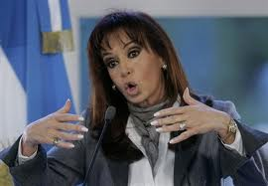Cristina Fernández

In Malmö, amongst police officers called Sweden’s Chicago, surely not because its a windy city, we have seen 5 open-street murders in daylight during the last 30 days. On New Year’s Eve the victim was a 15-year-old immigrant kid, surely a prospect member of a gang...00’s of 000’s of these can’t find a meaningful employment, despite politicians’ “everyone shall come on-board”.

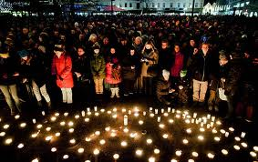Grief in Malmö.

Career politicians thrive on confrontation but where’s the freedom, where’s the future? All Europeans tend to be gloomy about its industrial prowess, and expect “real jobs” to come from handing out fat, or less fat, cheques. Let the entrepeneurs loose, let workers/employers negotiate salaries more freely; not merely for a 6-12 months trial period. A near-death experience might be crucial albeit, the comfort of the rich should not depend upon an abundant supply of the poor, not allowed to decide their own remuneration. The relative price of a day in hospital has increased 55 times compared with manufacturing a television set over the last generation. The solution is clearly not to build more hospitals, but there is a deadline and nature is red in tooth and claw.

Swedish writer Ivar Lo-Johansson became famouse for many writings; one, which stated by observation, that “each individual has to defend himself”. To dedicate one’s life, or part of it, defending all those persons/people/individuals/animals/organisms that can not defend themselves, because they are often the most progressive, creative, without exception filled with love, is noble. “Not being able to fend for oneself does not, per se, include all criminals”.

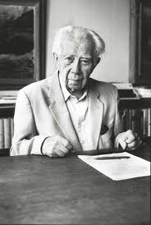Ivar Lo-Johansson

Mattias Flink, a Swede who shot to death seven young persons in 1994 has recently had his life sentence reduced to a time-limited one, i e two-thirds of 30 years, meaning he will be released during the summer of 2014. Bernie Madoff, the US former chairman of NASDAQ, although committing a hefty fraud amounting to roughly $22bn, has received 150 years without parole, and his eldest son hanged himself. Both of them, doing what they did, had with certainty received a single bullet in many countries, including China and Russia. “Life was never meant to be fair”.

One should bear in mind that most, if not all, criminal men, yes – serious criminals are mostly men – grew up without a regularily present father. Former US president Lyndon B Johnson stated, targeting a few unreliable political allies, in his starkly Texan accent: “its better to have them in the [election] tent pissing out, rather than outside pissing in”. Sentences should be given preventing future crime, and protecting society at large; not as a revenge. Natural brutality is something completely different, sometimes positive.

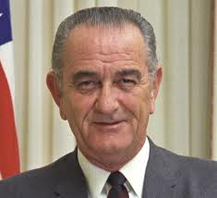Lyndon B Johnson

We support www.ncadp.org, and if you disapprove of Guantanamo Bay, which is by no means certain, there is also www.reprieve.org.uk . Its bad with them; maybe worse without them? To make lies sound truthful and murder respectable is not the point. Pro bono.

BENELUX: Tractabel, a very large Belgian engineering group, paid three men some $55m in commissions around 15 years ago, and this money still hoovers around these same men and their participation as directors of Eurasian Natural Resources Corporation – essentially a Kazakh miner. Alexander Mashkevich, Patokh Chodiev and Alijan Ibragimov – the trio of men/partners who owns 45 per cent of ENRC had not been able to sit on the board of their company after its 2007 flotation in London. After showing a record profit for 2010 amounting to $2.6bn, the Belgian court dropping its criminal charge, all three will join the board at the next AGM.

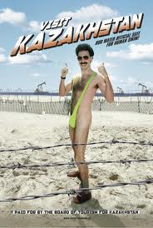Visit Kazakhstan.

ENGLAND: The voicemail interception, phone hacking and blagging scandal in England – with The News of The World and Rupert murdoch’s whole News International, the world’s largest news group, at its epicentre – continues and the UK premier David Cameron “urged the police to pursue their probe into alleged phone hacking by journalists in ‘the most vigorous way they can’”. Mr Cameron also stated that the hacking of Milly Dowler’s voicemail was a “truly dreadful act and quite shocking”. Milly Dowler was murdered when only 13 years old and was one of the most high profile criminal cases ever in the UK.

Rupert Murdoch’s son James, presently chairman of News International, had to feud off accusations of dishonesty, racketeering and incompetence from UK parliamentarians during a hearing. MPs accused him of laxity and – in one extreme case – running a mafia-style operation. Mr Murdoch jr denies a culture of “omerta”, albeit and alas, Glenn Mulcaire, a private detective, was paid more than £100.000 annually and had been given 2,266 “taskings” by various journalists. More than 16 people have been arrested over the phone hackings. To paraphrase Abraham Lincon: “You can’t fool all the people all the time”. Others would say “rien ne pèse tant qúun un secret”.

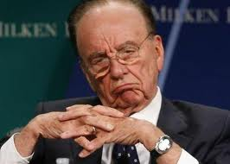Rupert Murdoch

-Michael Woodford, the ousted British chief executive of gigantic Japanese camera manufacturer Olympus, has finally returned to Japan to be interrogated by officials from the stock exchange police, finance prosecutors etc. This despite his fear or concern of a Yazoka – Japanese mafia – involvement. Mr Woodford, who started his career at Olympus as a junior account manager some 30 years ago, was appointed group chief executive and succeeded Tsuyoshi Kikukawa on October 1st, 2011.

As many newly appointed chief executives, Mr Woodford wanted to “clear the cup-board of skeletons” hidden for years. This “skeleton-manouvre” is done for many reasons: like any family or person moving into a newly purchased home; but more importantly, lowering the asset base by writing down values – disregarding market value on a listed stock – a new boss can show “a clean sheet” and an unsurpassed ROI – return on investment – over time, with himself at the steering wheel.

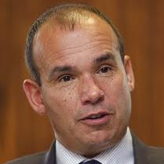Michael Woodford

No doubt, without knowing the individuals and their joint personal relationship, competition and testosteron levels, human nature generally might have played a large part. With convenient hindsight, we now know that Olympus, like so many Japanese companies during the 90s, had speculated heavily and lost upwards to $1.4bn, an amount that Olympus made tobashi – Japanese for “make fly away”.

The procedure involves accounting dodges used by companies to disguise investment losses, typically by transferring the lossmaking assets to allied firms or shell companies. This behaviour is certainly not unknown to western companies, widely seen at groups from Enron to Lehman Brothers. In a rudimentary accounting fix, in this particular case, the company acquires assets/other companies and overpays with an amount matching the previous loss, i e creating a good-will/intangible value to be depreciated over a 20-year period.

One might now expect an “impairment test” – an accountancy term for an assessment of the current value of the company’s assets on its balance sheet. An independent inquiry and a forensic audit might clear the air. Adding insult to injury, German prosecutors now claim Olympus Europe has shown breach of trust as early as 2003, paying out €640.000 for “no services rendered”. Mr Woodford, who was at that time manager of Olympus Europe, has turned the matter over to the German authorities. Clearly of deux origines – Mr Woodford is fired and Mr Kikukawa has resigned as chairman in “Le grand départ”. Olympus new president, Shuichi Takayama, said he believed the acquisitions had been conducted “appropriately” – omne homo mendax.

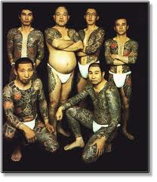Yakuza

Thanks to Mr Woodford’s tenacity, the case is under investigation by the US Federal Bureau of Investigation, the Securities and Exchange Commission, Tokyo prosecutors, the UK’s Serious Fraud Office and, not the least naturally, der Bundesfinanzpolizei – “Ordnung muss sein”.

-Allen Stanford, the now arrested owner and chairman of defunct Stanford International Bank, has had his knighthood revoked in England – cross our hearts – after criminal charges were filed. Mr Stanford, an American, was Antigua’s largest private employer and his bank was domiciled in St John’s, the capital of this Caribbean island. Of the $100m frozen in the UK, the liquidators have made an application for $20m to be released. Mr Stanford’s trial has been postponed to allow him to be treated for drug addiction.

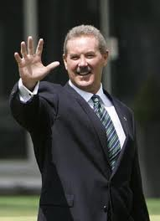 Allen Stanford 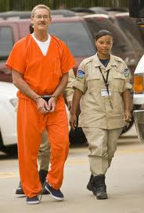

-Royal Dutch Shell has admitted liability and agreed to concede to the English jurisdiction and court system. A compensation for two oil leaks in 2008-09 to 69.000 Nigerians is expected to exceed $410m. The “core of the poodle”-point in this case is that a European Court of Justice ruling in 2005 made it easier for groups of litigants to launch legal action in European courts and gave claimants an automatic right to sue in the defendant’s home country. Rather than being fought out in local courts where litigation could last for years, and personal safety is at stake, there is a trend for claims to be brought in London’s High Court. Consider the Russian dispute, eventually to be settled in London, – between Berezovsky and Abramovich – and the legal fees involved; surely a gold mine for England.

-Bill Bratton – former police commissioner of, at different times, both LAPD and NYPD – was drafted in to advise David Cameron on gang culture and UK police organisation. “Morale is awful. All you have to do is read the police blogs,” Mr Bratton said of the Met. After rumours that the PM contemplated appointing Mr Bratton new Metropolitan Police Chief, an idea Sir Hugh Orde, president of the Association of Chief Police Officers, described as “plain stupid”, Mr Bratton retorted “that Sir Hugh was significantly affecting his own credibility by dismissing the idea that foreign police chiefs could lead UK forces”. Bernard Hogan-Howe, acting deputy chief, has by now – Dec. 2011 – been appointed as the new commissioner.

-Vodafone, the UK-listed telecoms group, has appealed to India’s Supreme Court over a $2.5 bn, no less, tax levied on it. The background to the case is that two Cayman Island legal entities exchanged the Indian assets of Hong Kong-based Hutchison Whampoa. Clearly Vodafone insists it is not liable for Indian tax, and consider the case a big test of India’s openness to foreign companies acquiring Indian dittos. Clearly, in any developed economy, no one would pay tax as a buyer of a foreign owned company, but a nice try.



-Kweku Adoboli, accused of unauthorised trading at the Swiss bank UBS, has probably caused a loss amounting to $2.2bn, making the rouge trading one of the largest ever – maybe comparable to Nick Leeson’s at Baring’s Bank. Mr Adoboli, originally from Nigeria, says he is “sorry beyond words” and faces two charges of fraud and two of false accounting. The next hearing is scheduled for December 20th, and bail was neither applied or granted for.

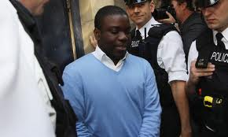Kweku Adoboli

-Victor Dahdaleh, a London-based British-Canadian leading businessman, was arrested in October, later released on bail, charged with corruption in relation to Alba, Bahrain’s leading aluminum smelter
and its import of bauxit (the raw material from which aluminum is extracted) from Australia. The UK’s Serious Fraud Office (SFO) claims Sheik Isa bin Ali al-Khalifo, son-in-law of Bahrain’s prime minister since four decades, Sheik Khalifa bin Salman, has received bribes from Mr Dahdaleh amounting to $6m during 2003-04. Bruce Hall, Alba’s former chief executive, has received bribes amounting to $1.2m according to the SFO, and he is requested for extradition from Australia where he is domiciled. This is a “critical point” in the five-year investigation according to a press report from Alba, saying it will continue pursuing “very large amounts of money” lost.

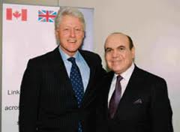Victor with BC.

FRANCE: Carlos the Jackal – does not sound like a nice man – has been in French prisons since his 1994 capture in Khartoum, convicted to life for killing two policemen and an informant. C-the-J, whose real name is Ilich Ramirez Sanchez, now faces a second term of life in prison, if he is convicted of killing 11 people and wounding an additional 200 in a bomb raid committed in the early 90’s.

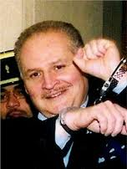Carlos the Jackal

-Dominique de Villepin, former French prime minister, was acquitted on appeal in the Clearstream trial, where he was accused of spreading false rumours, or allowing false rumours to be spread, about Nicolas Sarkozy, before the 2007 presidential election. However, separate allegetions emerged that Mr de Villepin and Jacques Chirac has/had received illegal donations from Africa; a fact both men deny.

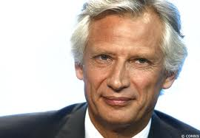Dominique de Villepin

-Manuel Noriega, 77, former president of Panama, has been extradited from the US to serve a 20-year sentence in France for human rights crime. Ronald Reagan, former US president, invaded Panama 20+ years ago catching Mr Noriega, who has spent a couple of decades in US jails for racketeering and drugs trafficking.

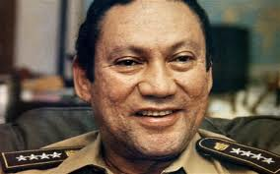Manuel Noriega

-The European Court of Human Rights in Strasbourg has received an appeal by a Muslim woman who was fined in France for wearing full-face veils in public. That fine was the first ever to be imposed and might herald a lengthy legal process throughout Europe – amongst minor stuff like the eurozone breaking down, oil embargoes against Iran etc. Well done, and make sure you earn your salaries benefitting the public..

Muslim women.

-Christine Lagarde, the International Monetary Fund’s boss, is to be investigated by a special court over her role in an arbitration panel’s award of €285m in damages to Bernard Tapie, a controversial businessman and friend of President Nicolas Sarkozy, when she was France’s finance minister. Ms Lagarde denies wrongdoing.

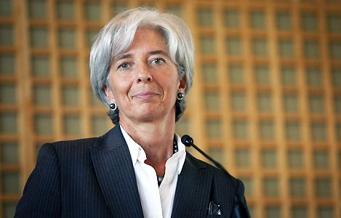Christina Lagarde

-Total, the giant French oil company, and its chief executive Christophe de Margerie, will stand trial over long-standing allegations of corruption linked to the UN oil-for-food programme in Iraq. Mr de Margerie denies any acts considered criminal, alongside 18 other individuals/managers involved.

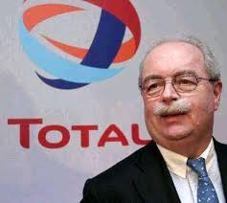Christophe de Margerie

-Alstom, a French engineering group employing over 75.000 people, has been ordered to pay €31m by Switzerland’s attorney-general for negligently failing to stop bribery by some employees. This is one of the most significant rulings yet in international criminal probes into alleged systematic corruption. The attorney-general accused Alstom of “failing to meet the standards for such an international group”. Interesting that also Britain’s Serious fraud Office, the SFO, who has been working closely with the Swiss A-G, and Brazilian prosecutors also have unveiled large investigations of purported graft.



-DSK, Dominique Strauss-Kahn, had hopes of becoming the next president of France, but no longer.The many affairs of the aging adultère, once the great leader for the Franch socialists, and former chief of the IMF (International Monetary Foundation) is a sad story – as it went public. The little affair, revealed shortly after the great one in New York, entails a young French writer, where a court has acquitted DSK and labelled the “forcing himself on her – pushing her to the floor” case “could be qualified sexual assault”, however, a denial makes no case possible.

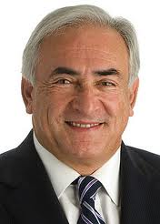Dominique Strauss-Kahn

The big affair involves most things: a missing BlackBerry mobile device, probably hacked by the competing UMP, President Sarkozy’s centre-right political party, where in their Paris office DSK’s e-mails to his wife Anne Sinclair have been seen; a black African model from Guinea, Nafissatou Diallo (1.78 meter tall), who claims DSK raped her and somehow can substantiate it whence his semen is found mixed with her saliva; an arrest of DSK after he has boarded a flight from NY to Paris. DSK was released “a great many days later” and Ms Diallo’s credibility severely under stress through lies. Prosecutors concluded that a “hurried sexual encounter” took place, consentual or not.

Nafissatou Diallo

France retains the sexual morality of village and hierachy, but it is an anachronism and most Frenchmen, maybe not women, will simply state – “Un homme”. However, the extreme legalism of US attitudes comes not from puritanism but from diversity. Legalism is what you get when nothing can be agreed upon. Most European legal systems assume a common moral code. The US system is designed to regulate interactions among highly mobile drifters who may be some place far, far away tomorrow. Rape seems a more present danger under such circumstances. A rich foreigner is also a maximum flight risk.

-Anne Lauvergeon, former chief executive of Areva, the French nuclear power group, and her husband have filed a legal complaint over alleged phone-tapping, related to the Areva acquisition of a uranium miner in 2007 for €1.9bn. Ms Lauvergeon, also eloquently nick-named “Atomic Anne”, claimed in November that unnamed Swiss private investigators had eavesdropped on her for months.

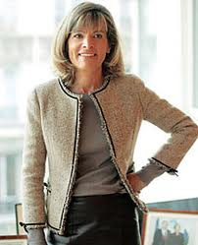Anne “Atomic” Lauvergeon

GERMANY: In a federal court in New York, six former Siemens executives have been charged with bribing/conspiracy to bribe senior Argentinian government officials to win a $1bn contract. It all centres around an identity card project, later cancelled, where “bribes were sought by and paid to Argentinian government officials, up to and including the president and cabinet ministers”. The executives allegedly hid payments through tens of offshore companies and it is the first time a board member of one of the world’s 50 biggest companies has been charged according to the US Foreign Corrupt Practices Act. Rough seas make good sailors, offshore ones!

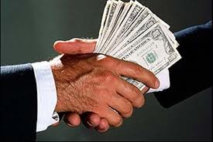Bribing.

-MAN, the truckmaker controlled by Wolkswagen, who also is a majority owner of Swedish trucking manufacturer Scania, has settled a long-running dispute with Abu Dhabi’s International Petroleum Investment Company, by agreeing to buy back a majority stake in German industrial group Ferrostaal and sell it on. The initial sale ran into the wall after German prosecutors began to investigate bribes paid out in relation to Greek and Portugese submarine contracts. Ferrostaal AG has offered to pay fines amounting to €150m in a later settlement. Alle wunschen unser Geld!



-Helmut Kiener has been sentenced to 10 years in prison after running a “Ponzi scheme” investment type throughout Germany. The fund known as K1, defrauded Barclays Bank of €147m, BNP Paribas of of €42m with the rest of losses amounting to in total €345m spread amongst smaller investor. Dieter Frerichs, the managing director of the funds, committed suicide in Spain after police attempted to detain him to carry out an extradition order issued by Interpolice.

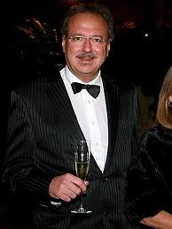Helmut Kiener

-Siemens (again) has in total paid out over €2bn in fines and advisory roles regarding bribes/corruption practices carried out by its managers in Brazil. The head of Siemens in Brazil has left the company after Europe’s, by all measures largest engineering group, uncovered “serious compliance violations”. The case has meant the departure of dozens of Siemen’s senior managers, although no serious, hopefully, “brain drain” has occurred.

-Daimler AG, more known as the mother of Mercedes-Benz, has removed its long-serving head of its US business, Ernst Lieb, after irregularities in the “human resources area”, i e household costs. After a serious of damaging corruption scandals at companies including Siemens, Volkswagen and Daimler, the latter has issued a “zero-tolerance” policy amongst all managers. The company has become very aggressive in tackling these issues and the share price has almost halved over the last six months, perhaps for other reasons.

Mercedes-Benz

-One of the most spectacular legal trials in Germany, with over 40 witnesses expected to give evidence, regards BayernLB’s, a Munich-based bank, sale of its stake in F1, the motor sport circus group, to CVC, a private equity group. Gerhard Gribkowsky, a director of the bank, allegedly received $44m in bribes from Formula One boss Bernie Ecclestone. Mr Ecclestone has put forward a threat from Mr Gribkowsky, that UK tax authories might be inclined to look into the dealings of Bambino, a trust set up by Mr Ecclestone, but now run by Slavica Ecclestone, the former wife of Mr Ecclestone, who also states that Slavica and Mr Gribkowsky had a close relationship, close to “drinking partners”. That Slavica Ecclestone is not une couveuse seems the only thing clear in this case. “Er war um das kleinste besorgt, weil er das grösste wollte” – did Goethe write about Napoleon Bonaparte – in another dimension of regional acquisitions en masse.

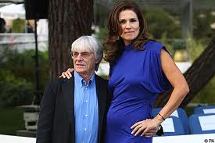Slavica Ecclestone

-Rolf Breuer, former chief executive at Deutsche Bank – Europe’s and Germany’s biggest ditto, has agreed to pay €350,000 settling a dispute regarding the bankruptcy of Kirch Group. The late Leo Kirch, who died at age 84 this year, long sought more than €2bn in damages from Deutsche Bank after Mr Breuer in TV claimed the Kirch group had serious financial difficulties, leading indirectly to its demise.

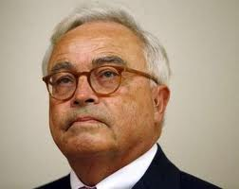Rolf Breuer

-VAT Carousel Fraud: up to six people have been convicted of tax evasion in Germany after an international probe into carbon emissions trading. One of the biggest European Union investigations have found traders created transactions to evade value-added tax and up to 170 individuals are under scrutiny and interrogation. The total tax evasion value adds up to €850m, and six traders from Germany, France and England have already received sentences ranging from between three and seven years for frauds amounting to €300m. Up to 1.000 inspectors, detectives and other law enforcement officers have been involved and Europol estimates the trading schemes had cost taxpayers €5bn.

-Deutsche Telekom and Magyar Telekom, its Hungarian subsidiary, has paid US authorities $95.2m to settle allegations that executives had bribed government officials in Montenegro and Macedonia. This Foreign Corrupt Practices Act gives the DOJ (US Department of Justice) and, yes, the SEC (Securities and Exchange Commission) – both American – the power to demand fines for corruption worldwide. “Geld spielt keine Rolle” was the Wehrmacht motto between the wars.

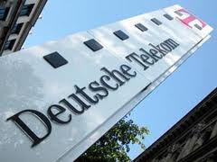DT

GREECE: At a public discussion on tax evasion organised by two Greek think-tanks, an Athens consultancy and a civil society group, it was revealed by a former senior Greek finance ministry official that indigenous tax collectors routinely pocket 40 per cent of fines imposed. Wealthy individuals, family-owned companies and self-employed professionals – seen as the nation’s biggest tax evaders – often utilize the long-established practice know as “40-40-20” formula. The tax evader receives a discount of 40 per cent on the agreed fine, while the tax official takes another 40 per cent – effectively a bribe. The state receives only the remaining 20 per cent. Vilfredo Pareto, an Italian economist, instituted the 80/20 rule, depicting the fact that 20 per cent of the Italian population owned 80 per cent of the assets. In mathematical statistics the “Pareto principle” is a simple example of a power law. Now we have seen a Greek mathematical version of dividing monetary assets, however more fluid. Greece loses revenues of €6 to €9 bn annually due to tax evasion, probably a lot more, in percentage more than any other eurozone member.

More than 50 Greek businesspeople with individual tax debts exceeding €100.000 have been arrested, although none has yet appeared in court. Evangelous Venizelos, Greek finance minister, has announced plans to accelerate criminal procedures against tax evaders – “pushing the pedal to the metal” – however, no road-map or time-table has yet been announced.

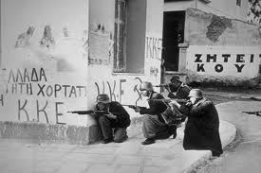SS in Greece.

HUNGARY: Have the socialist-led coalitions “committed a political crime against the Hungarian people”? State debt has risen from 53 per cent of gross domestic product in 2002 to 80 per cent in 2010, and three former (socialist) prime ministers should be held responsible, says Viktor Orban, Hungary’s PM. This could certainly provoke alarm among officials in other countries, and could set an international precedent. Prosecutors in Ukraine won their case against former PM Yulia Tymoshenko (see below), and she was recently convicted to 7 years in prison for allegedly causing the nation damages of up to $190m by signing an un-authorised gas deal with Russia.

Mr Orban, and his majority-led parliament, has enacted a law that revokes the right of banks, an overwhelmingly majority foreign-owned, the right to demand repayment in Swiss Francs of lending contracts denominated in this currency. Instead, lenders are allowed to repay principal and interest in Forints – at the initial contract rate naturally – giving them a discount of perhaps 50 per cent, causing an identical loss for banks. This is not a crime against the Hungarian people, but, indeed is it “force majeure” or pacta sunt cervanda? Mr Orban probably argues sui generis – one of a kind – but but...

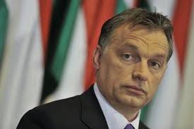Viktor Orban

ICELAND: Ögmundur Jónasson, Iceland’s interior minister, says the rejection of an application by a Chinese businessman, Huang Nubo, to buy a 300 sq km tract is because it breached rules on real estate investments by non-European groups. To make an exception would set a “dangerous precedent” according to Mr Jónasson, and we have no intention of breaking the rules. Supposedly, Icebank did neither!

Iceland

ITALY: Now the country has a new prime minister appointed not through democratic elections but by the 84-year old President, Giorgio Napolitano; “Super-Mario Monti, the new PM, a former academic and EU bureaucrat might provide what Il Playboy – Il Kardinale – Il Cavaliere – Il Padrone could not. Italians readily give nick-names to popular, and un-popular, front figures and we all remember, don’t we, Il Avvocato – Giovanni Agnelli/CEO of Fiat; Il Ingenieur – Carlo De Benedetti/CEO of Olivetti; Il Duce (The Leader) – Benito Mussolini, amongst possibly many more only known by the indigenous population.

The French and German leaders had earlier publicly dismissed Silvio Berlusconi’s credibility, forcing the government of the eurozone’s third-largest economy, and the world’s eight-largest, to draft a letter of intent outlining the reforms it would enact and a timeline to deliver them. Corruption seems ripe in Italy, whether via Cosa Nostra – Our Cause, or not, and parliament has for the first time stripped an MP, Alfonso Papa, from Berlusconi’s party of his immunity from arrest. Accused of corruption, Alfonso Papa was taken to a Naples prison, protesting his innocence, where he remains under preventive arrest. La Republica, a centre-left daily, notes at least 84 MPs – a tenth of parliament – are under investigation, awaiting trial or already convicted. Mr Berlusconi has been cleared in his 25th trial – a fraud and embezzlement case related to Mediaset, his private broadcaster, but he is not satisfied: “I am not because I have been accused of an absurdity. It is a serious scandal that prosecutors accuse me, and their colleagues clear me.”

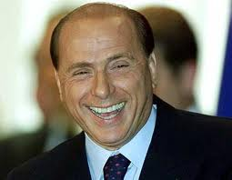Silvio Berlusconi

In a police-intercepted phone call released in court documents, Mr Berlusconi allegedly said: “I am going in a few months.... I will quit this shitty country.... I am sick of it.....” Unofficially German police intercepted Mr Berlusconi’s telephone when he was in Berlin, according to many sources, where he explicitly depicted Angela Merkel, Germany’s Chancellor, as a c o w, bringing a serious German government debate to a point where they contemplated withdrawing their Ambassador from Rome. “In Rome do as the Romans do”. [It is a terrible thing that phone-tapping seems more and more common, for whatever purpose and by whomever – not to mention using internet-leaking devices].

Once asked when Barack Obama was elected president, of his opinion, Mr Berlusconi’s immediate reply was: “He’s got a nice tan, anyhow”. Well, commedia per eccelenza and la commedia è finita, now that Mr Berlusconi only has three court charges left: three of Mr Berlusconi’s associates should stand trial on charges of procuring prostitutes, including Karima El Mahrough, a Moroccan nightclub dancer, who was 17 at the time of allegedly being paid for “services” by Mr Berlusconi, services not specified or agreed by Mr Berlusconi, whose trial for this will follow naturally, and is timed to begin in February 2012; and two trials await him for bribes-giving. Ad astra per aspera – To the stars through difficulties. Bear in mind Mr Berlusconi still controls the largest parliamentary block in Italy – Forza Italia. He will surely be missed by us, although “cemetaries all over the world are filled with indespensable men”. Mementi mori.

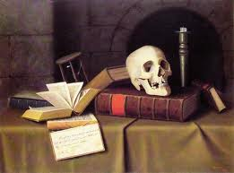Mementi mori.

-Executives from Lactalis, a secretive French dairy company, have finally taken control of the Parma-based dairy group Parmalat, ousting Enrico Bondi, its septuagenerian chief executive and one of Italy’s most feared and respected corporate leaders. Many expressed views of disgrace and “Parmalat should have stayed in Italian hands”. The €14bn ($20bn) accounting fraud earlier uncovered at Parmalat is the biggest ever to have occurred in Europe. Cesare Geronzi, former chairman of Assicurazione Generali, Italy’s largest insurance group, and Matteo Arpe, former managing director of Roman bank Capitalia, have been given prison sentences linked to the Parmalat collapse. Mr Geronzi, 76, is to spend five years behind bars and Mr Arpe, who calls the ruling “paradoxical”, three years. Under the Italian justice system, none of the accused is likely to spend time in prison, unless convicted at the end of a very lengthy appeals process.

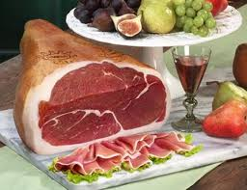Parma ham.

-Is science itself on trial in Italy? Six scientists and one public official are on trial charged with manslaughter – for failing to give adequate warning that an earthquake was about to devastate the city of L’Aquila in 2009. Five thousand scientists have signed a letter of protest, referring to the treatment of Galileo four centuries ago, addressed to Giorgio Napolitano, the Italian president. Prosecutors claim the seven experts misled people into thinking that precautions were unnecessary, however, and whatever, their scientific conclusions were made in good faith. This will no doubt deter scientists from taking part in any predictions, of any kind. The L’Aquila earthquake in 2009 killed 309 people and the city government is seeking damages of €50m.

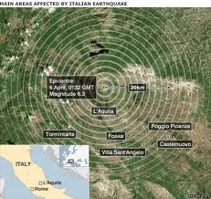L’Aquila

-If tangentipoli – “bribesville” survived the corruption prone Italy of the 90s, Super-Mario Monti surely has something to bite into. Corruption in the public sector costs Italy some €60bn annually, according to Corte dei Conti, which oversees state accounts. It is estimated that the Camorra and the Cosa Nostra together have revenues exceeding $180bn annually. Transparency International ranks Italy 67th in its global Corruption Perception Index, between Rwanda and Georgia. In his dual role as finance minister, Mr Monti is directly responsible for the state’s 30 per cent controlling stake in Finmeccanica and its 100 per cent holding in Enav. There is an excellent new book, translated into Swedish by Helena Monti, “Mafia Export” by Francesco Forgione, for those who wish to dwell deeper into the trails of global criminal organisations.

Shares in Finmeccanica, a colossal defence group, have lost some 60 per cent of their value on the stock market during the last months, and Lorenzo Borgogni, its director of external relations, has stepped aside while under investigation for corruption. Pier Francesco Guarguaglini, 74, and Finmeccanica’s veteran chairman, who is under investigation in connection with alleged false accounting, has finally resigned or being fired – receiving a €5m “golden good-bye”. Guido Pugliesi, chief executive of Enav, was placed under house arrest in mid-November for similar reasons as Mr Borgogni’s.

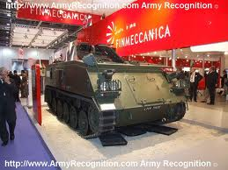No false accounting at Finmeccanica!

NORWAY: Telenor, the Norwegian mobile operator, will refuse to pay a $400m tax bill from the Bangladeshi government, and the Bangladesh Telecommunications Regulatory Commission (BTRC) will pursue all available legal options. The bill covers an unpaid share of revenues (of an affiliated company), accumulated interest and unpaid tax on SIM cards.

POLAND: A brutal murder of an elderly couple, aged 70 and 71, occurred 60 km’s north of Göteborg/Sweden in a small village during October. The safe vault, weighing 125 kg’s, is missing and 2 males, aged 34 and 41, in Poland has been requested for extradition in connection with the murders. Poland has by Transparency International been marked as the secondly most corrupt country in the EU, after Bulgaria, and there are 27 countries!!!

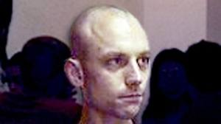You know this Polish man?

-The latest in a recent series of racist and xenophobic acts of vandalism targeting the small Jewish and Muslim communities in eastern Poland, involved defacing a monument to victims of a second world war pogrom against Jews in Poland. The tiny Lithuanian minority has also been affected by threats and violence in daylight.

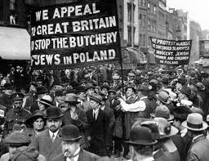Polish pogrom.

RUSSIA: In Strasbourg, the European Court of Human Rights, has freed Russia from the accusation of attacking Yukos, and its management and owners, by misusing its legal system. The company’s claims, amounting to totally a record $98bn, was based on tax levies and the expropriation of almost all of Yukos and its assets. The ruling handed a victory to Moscow and Russia declared itself satisfied. Mikhail Khodorkovsky, the majority owner and president of Yukos, who posed a political challenge to the Kremlin remain firmly in prison, since his arrest in 2003.

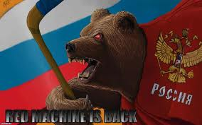Russian bear

-During the first six months of 2011, over 183.000 policemen have been sacked in Russia for corruption, general graft etc. Rashid Nurgaliev, interior minister, states that police corruption “does not exist today” in Russia.

-Alexander Lebedev, owner of London newspapers The Independent and the Evening Standard, has had his lawsuit against the FSB thrown out by a Moscow court. FSB, the successor to the KGB, which is a virtual state within the state and thought to be all but immune to the law – which may still be the case – was accused of having made a raid by masked special forces of Mr Lebedev’s National Reserve Bank. Mr Lebedev claims damages of $11m, and might proceed to a higher court instance shortly.

-Alexander Lebedev, the same for sure, has been sued in Britain by Russian property developer Sergei Polonsky for libel, saying Mr Polonsky “deserved an earlier beating” in a television talk show. Mr Lebedev claims Mr Polonsky had insulted him for over 90 minutes without interval, and so....
“Självhävdelse till varje pris; självförverkligande också med livet som yttersta insats”.

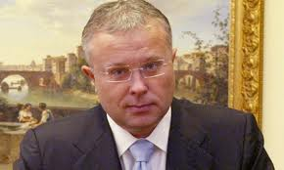Alexander Lebedev

-The US has been banning a number of Russian officials from entering the US, seen as a compromise by the US state department, heading off legislation that would have imposed broader sanctions on Moscow for human rights violations – known as the Magnitsky act. The bill is named after Sergei Magnitsky, a Russian lawyer working for a US company, who died in prison in 2009. Were the Magnitsky Act to pass, the Russian government has warned Washington that it would retaliate “asymmetrically”, possibly by slashing transit of Nato supplies to Afghanistan through Russian territory, and possibly by ending co-operation on sanctions against Iran and North Korea.

Magnitsky was imprisoned in 2008, after accusing police officers of a $230m tax fraud, and died in November 2009, having been denied, allegedly, urgent medical care. Other well-known cases include journalist Oleg Kashin, who was beaten up last year; Anna Politkovskaya, a reporter who was murdered in 2006; and human rights worker Natalia Estemirova, murdered in Chechnya in 2009.

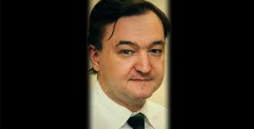Sergei Magnitsky

Moscow’s respected Kommersant newspaper said Russia’s foreign ministry had already drawn up a list of US officials who would be barred from entering Russia in a tit-for-tat response to the US ban. The Kommersant article said Russia might retaliate against US officials involved in cases such as that of Viktor Bout, the alleged gunner runner extradited from Thailand to the US late last year. Another such case is that of Konstantin Yaroshenko, a convicted Russian drug smuggler arrested by US special forces in Liberia last year. “In the last few years we have regularly been witnesses to blatant violations of the rights of Russians, and the application of US laws to Russian citizens and Russian companies in an extra-territorial manner. This is unacceptable and must not go without a response”, an official statement declared. Da, pravda!!!

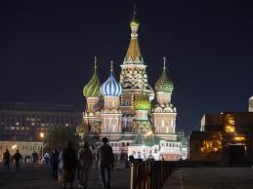Moscow

-In accordance with a shareholder pact that grants TNK-BP the right of first refusal to any big new projects in Russia or Ukraine – which BP and its chairman completely neglected -, minority shareholders have increased their damages claim over the UK oil group’s failed strategic alliance with Rosneft to $13.2bn. BP, and no doubt its two-tongued chairman, says the claim is “groundless” and “absurd”.

-The long-running legal saga between two Russians, who grew extremely rich by exploiting political ties to buy assets from the state at knock-down prices, continues in London. Roman Abramovich and Boris Berezovsky avoid each other’s gaze in the courtroom, while both are being cross-examined for weeks. Mr Berezovsky claims he owns – or owned – a large part of Mr Abramovich’s raw materials group. The only Russian word left untranslated in the registration of the trial is krysha – Russian for roof – meaning political or physical protection. Explaining why Mr Abramovich stayed out of a large aluminum industry deal, he only stated that “every three days somebody was murdered in that business”; reassuring for sure! Lawyers and accompanying “gorillas” can count on some hefty remuneration.

Krysha.

-From Moscow with Love: is Ekaterina Zatuliveter, a 26-year-old Russian national with residence rights in the UK, a spy officer with links to Moscow’s intelligence agencies, The FSB, SVR or GRU, or is she no more than “an ambitious young woman with political interests”? MI5, who wants her deported back to Matuschka Rossiya, could produce no hard evidence that she is a spy and Britain’s Special Immigration Appeals Commission found in her favour. Clearly, in 2006, she had an intimate affair with an MP on the UK’s House of Commons defence select committee, and in 2009 she had another ditto with a senior Nato official working on relations with Russia. The judge stated: “One would not imagine Paris taking this route” and “we should be under no illusions about the FSB, which is an extremely capable, well-resourced organisation whose methods are highly advanced”.

Ekatarina Zatuliveter

-IKEA has had three Moscow-based managers, one a Swedish citizen and two Turkish ditto, being charged with criminal conduct against a possible tenant at an Ikea-owned mall. They had, allegedly, hold back a lease agreement – until paid $480.000.

Doing business in Russia can still raise a skeptical eyebrow, but today risk is everywhere you look, and often where you least expect it – as sadly demonstrated by the collapse of some “more sophisticated” EU economies. Russia is a country with very clear rules, so turn the challenges into opportunities. The strategic logic of being there is compelling. Volte-face, some states such as Lithuania are preparing to welcome Russian investors with open arms. Vitas Vasiliauskas, the country’s central bank governor, told us recently that he did not care whether investors were from Russia, China or Mars. Others, such as Poland, have regarded Russian investments with horror.

Yuri Gagarin

The sale of Lotos, Poland’s second-largest oil refinery, has been pushed back after a member of the opposition party claimed he would make the Polish treasury minister stand trial if Lotos were sold to a Russian company. Poland gets two-thirds of its natural gas and almost all of its crude oil from Russia, and some politicians are nervous about closer ties with their powerful eastern neighbour. These old stereotypes are, we find, very dangerous and “where will central and eastern Europe get oil and financing if the Russians are not interested, at this delicate stage of world economic development?”, one asks.

SPAIN: Iñaki Urdangarin, the Duke of Palma, and also no less than the son-in-law of Spain’s King Juan Carlos, has been charged with corruption of tax payers’ money, fraud and falsification of documents. The palace said it would respect the decision of the courts and has suspended his official functions – stating that he has “not behaved in an exemplary fashion”. Jaume Matas, the former Balearics premier, is also co-charged.

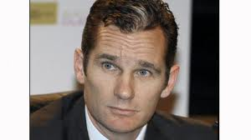Duke of Palma

SWEDEN: Teliasonera, a nordic telephone operator, has sued Cukorova (a Russian investment group) for not following the contract to sell its 13.8 per cent of Turkcell, a Turkish mobile operator with a market capitalisation of $10.7bn, and a 54 per cent share of Turkey’s mobile market. The International Chamber of Commerce in September ordered Cukorova to pay damages of $932m plus interest. A court, whether Kangaroo or not we don’t know, in British Virgin Islands, ruled in July that Cukorova should hand over its stake to Altimo, the telecoms arm of Russia’s Alfa Group. The case is likely and ultimately to be decided by the UK Privy Council. Caveat emptor – Buyers beware.

-SAAB, and other European defence groups, are to be probed concerning corruption regarding the 1990s deal worth $4bn providing South Africa with among other stuff, Gripen fighter aircraft. Corruption charges were even earlier brought against Jacob Zuma, SA’s present president, but these have been dropped.

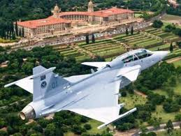SAAB Gripen

-Vladimir Antonov, among other things the “hidden owner” of SAAB Cars, was briefly arrested in London in relation to the bankruptcy of Snoras Bank, a Lithuanian outfit of Antonov’s empire. Mr Antonov has been released on bail, allegedly set at £75.000.

-New Wave AB, a listed Swedish presents- to promotion group that owns among other brands Orrefors and Kosta Boda, has been defrauded by the former managing director of its German subsidiary to the tune of SEK25m. Torsten Jansson, New Wave’s president and majority owner, deplores the situation, albeit will enhance economic control systems for the future. Better late than never!

-Nordea, the Swedish/Nordic banking group, has vigorously defended itself after Pandora, a multinational Danish jewellry company, lost 70 per cent of its value shortly after its IPO; an initial public offering sponsored by Nordea. Danish regulators have in December asked police to investigate the bank over the stock offering, since Nordea did not disclose its part-ownership in Axcel, which owned 60 per cent of Pandora before the flotation.

UKRAINE: Yulia Tymoshenko, former Ukrainian prime minister, denounces the court case against her as a lynching and accuses Viktor Yanukovich, Ukraine’s president, of orchestrating the trial and sentencing of 7 years in prison, to crush someone he saw as a “dangerous political rival”. She was found guilty of exceeding her authority when brokering a 2009 natural gas agreement with Russia. Prosecutors say the deal damaged Ukraine’s economy. EU leaders had warned that a guilty verdict could prolong a closer integration with Europe. Ms Tymoshenko will “under no circumstances” seek amnesty from Mr Yanukovich. Branislaw Komorowski, Poland’s president, said Ms Tymoshenko’s imprisonment will continue to harm Ukraine’s prospect of concluding an association agreement with the EU – a stark warning!!!

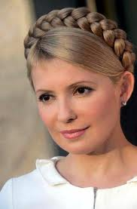Yulia Tymoshenko

A statement by Poland’s foreign ministry called her detention “too precipitous and drastic a step”. Radoslaw Sikorski, Poland’s foreign minister, also wants to personally “tip his toes into the water” when stating that “the influence of religion is underestimated”, and an imminent trade deal would wrest Ukraine from Russia’s orbit. “It is better to be Socrates unhappy than a Pole happy”, someone said.

We, at Walhallen Europadetektiv, find this attitude unprofessional – even silly. If completely free markets and liberal democracy were the endpoints of man’s political and economical evolution, we wouldn’t be were we are at present. However, the development of capitalism is never a pleasant experience, albeit and alas, you should not assume it is a movement for growth that relies on: uklad – local corruption, cheap labour and, above all, rule-bending, as in Poland. Capitalism is successful not because it stays the same, but because it does not. Successive governments in the western world have in fact bribed their electorates, in order to get re-elected, with promises their tax streams could not sustain, and so produced budgets that piled borrowing upon borrowing, culminating in the massive deficits now afflicting all their electorates.

Ukraine, this formerly centerland of the Rus people (see www.wikipedia.org/rus people), and where 80 per cent of the population in Kiev [Kiev in Russian, Kyiv in Ukrainian] speaks Russian at home [even Yulia Tymoshenko is a native Russian-speaker from Dnepropetrovsk], may wish to define their own destiny, as they now have done at free elections, and not being a religious and economic disciple of mighty Poland.

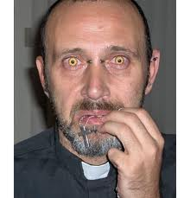Polish priest.

We all remember, or should remember, Poland’s insistence of having the same voting power as Germany within the European Union – after being invited to participate – which made many sane people flabbergasted. Competing with the Jewish people about being the paramount victim of the 2nd WW simply doesn’t hold – remember Poland’s acquisition of territories in northern Carpatia 1938 and numerous pogroma. Iosif Vissarionovitj Dzjugasjvili, a k a by his nom du guerre Josef Stalin – Stalin meaning “Steelman” in Russian – stated that running Poland was “like putting a horse-saddle on a cow – it works but slowly”, and his eternal arch foe in Niemcy [Germany], meaning numb amongst Slavic-speaking people, viewed that “reason does not prevail in Poland”. Maybe they were both right!!! Before investing in Poland, bear in mind this people have their “own agenda” and tonnes of “Schadenfreude”.

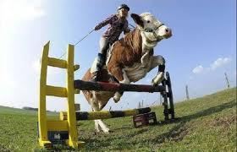Polski karova – Polish cow.

Poland has also tried intensively to block Northstream, the gas pipe-line between Russia and Germany under the Baltic Sea, insisting it should be laid over Polish soil – for reasons even a juvenile delinquent can figure out. One day they will cut the supply, or threaten to disrupt vitally her “enemies d’heritage”. As a Polski journalist in Warsaw told a representative of Walhallen Europadetektiv during the last New Year’s Eve celebrations in Poland, during the first few hours of this incumbent year: “You Swedes understand nothing, or little. We Poles starkly dislike Germans and Russians, but we hate Ukrainians”. I think the reciprocal feelings from Ukraine are more mature and prudent.

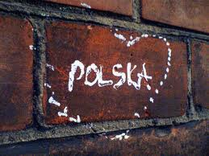Polish love.

When the Polish Airforce TU-154, carrying 96 people including the Polish president Lech Kaczynski and his wife, former president Ryszard Kaczorowski, the president of the National Bank of Poland, amongst many other dignitaries, crashed in April 2010 killing all on board, enroute to visit Smolensk honouring the victims of a Katyn massacre in 1940, Polish authorities and media blamed the FSB of Russia for somehow causing the incident. The Polish military pilot did not have a licence to carry passangers on this type of aircraft, no required and approved flight plan was filed, Smolensk airport was closed due to severe weather/fog and is not equipped with ILS (Instrument Landing System) and only ADF (Automatic Direction Finder)-carrying planes could home in on their NDB (Non-Directional Beacon), the latter a simple FM-radio station. As commanding aircraft pilot I have flown numerous times through Polish airspace, also during Soviet and Warsaw Pact-times, under severe weather and storm, but never, never would I behave as preposterously irresponsible as this; if so, a certain jail sentence would be received, as well as a revoked pilot licence.

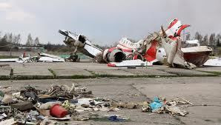Polish Airforce TU-154 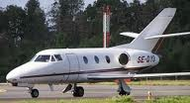Swedish jet

One should also be aware of the fact that Slavic as opposed to Germanic are two completely different descriptions/denominations: Slavic is a language-based denomination, streching geographically from e g Belgrad to Sczcecin to Vladivostok, while Germanic is a racial tribe denomination originally, including only north/north eastern/north western European people. Rus people/Varangians originated in Scandinavia, as even Leo Tolstoy mentions in his epic novel “Anna Karenina” – once filmed with the great and only Greta Garbo as Anna. Grouping together Russians, mentally - racially – culturally, with e g the Polish people is, we want to clarify, simply wrong at source and overall.

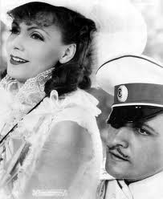Greta Garbo

Ms Tymoshenko, and Pavlo Lazarenko, former prime minister during the early 90s and currently in a US prison for money laundering, faces new prosecutions of corruption. The latter allegedly used his authority to provide “state guarantees” for Russian gas imports to a company, conveniently owned by Ms Tymoshenko, that failed to pay a $405m bill to Russia, whose obligation hence fell upon the Kiev government. Up to $1bn in total was funnelled into offshore accounts according to prosecutors. They both face an additional decade or so, if convicted, in a prison, hopefully not Lubyanka – the formerly well-known KGB resort in Moscow. Maybe some leniency will be considered – and as someone in Odesa wrote on Twitter: “ Soon you won’t be received in polite society without a spell in jail”.

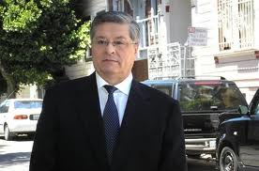Pavlo Lazarenko 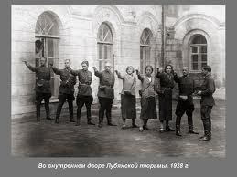Lubyanka

USA: US prisons, banned from buying prescription drugs in Europe, e g sodium thiopental, used as “execution cocktails”, are now stepping up efforts to acquire them from other countries such as India. Lundbeck, a Danish pharmaceutical company, has tightened supplies of drugs used for the death penalty and an European Union-wide regulation was issued in November. Lady Ashton, the EU’s high representative, said “The European Union opposes the death penalty under all circumstances”.

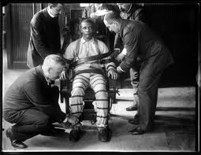

-The Bernard Madoff case continues. Irving Picard, the legal adminstrator, has so far collected $8.7bn – roughly half the $17.3bn in funds estimated to have been lost by customers to the fraud. The late Jeffrey Picower’s estate agreed to pay $7.2bn to victims, and another early investor, Norman Levy, has agreed to pay $200m. Mr Picard’s law firm, Baker Hostetler, has received “hundreds of millions” of dollars which makes many victims highly critical and one says “it is indicative of a broken system”. Another states that “the more powerful you are on Wall Street, the less likely you’re going to be scrutinised”. Whether there is a long-term erosion of trust in the financial system, we can only guess.

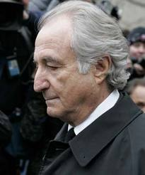Bernard Madoff

-Judge Richard Holwell handed down an 11 years-in-prison sentence to Raj Rajaratnam, the billionaire US hedge fund manager born in Sri Lanka 54 years ago. Mr Rajaratnam was also ordered to pay a $10m fine, plus $53.8m in restitution. The prison term was “highly likely to act as a strong and necessary deterrent”, the judge said. Mr Rajaratnam will be detained at the prison at Butner, North Carolina – the same where Bernard Madoff resides.

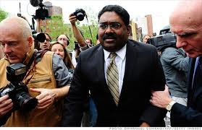Raj Rajaratnam

-State Street and Bank of New York Mellon both practice deceptive foreign currency exchange schemes, according to Harry Markoplos. Mr Markopolos, who unsuccessfully tried to expose Bernie Madoff for years, is now an independent fraud investigator, who has helped building cases against many banks resulting in probes in Ohio, California, Florida and Virginia.

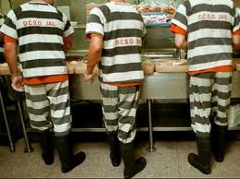Deceptive banks.

-Allen Stanford, the Texas financier accused of running a $7bn Ponzi scheme, similar to Mr Madoffs, claims he lost all memory after a 2009 violent jail assault. A prison doctor stated Mr Stanford faked -“blatantly simulating cognitive defects”. A federal court in Houston will decide whether the trial scheduled for Jan. 23rd can/will proceed.

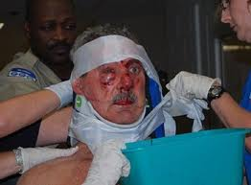Allen Stanford after assault.

-Gary Foster, a former vice-president of Citigroup, was arrested and charged with embezzling $24m from the bank and depositing it into his personal account. Authorities allege he used eight transfers from early 2009 to late 2010 to wire the money, and he was immediately arrested at John F. Kennedy airport in November 2011, after returning from Bangkok.

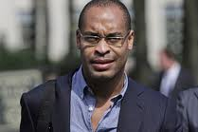Gary Foster

-The US Securities and Exchange Commission is suing four Chinese citizens on civil charges of insider trading, for allegedly making more than $11.2m in illegal profits. Pearson, the giant listed newspaper group, bought Global Education and Technology, a language-testing company, and it is “to be proofed” that Lili Wang, a 45-year-old Beijing resident, was allegedly “tipped about the acquisition” prior to its public announcement.

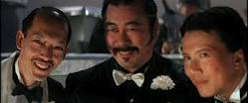Greedy?

-The US Department of Commerce has blocked Huawei, the Chinese telecoms company, from participating in building a national wireless emergency communications network. William Plummer, Huawei’s vice-president of external affairs, comments on this and the fact that his group has been barred from supplying Sprint, a big US telecommunications group, with equipment by depicting that “the shoe is on the other foot” – meaning transparancy is lacking from the US.

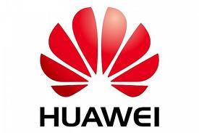Huawei

-See no evil, hear no evil, speak no evil: a whistle-blowing charity, Public Concern at Work, has been set up in the US and the incoming chairman, Carol Sergant, says “there are brave and ethical people who want to speak out”. We have seen, she said, “governments around the world have cracked down on financial institutions and stepped up enforcement of corporate bribery bans”. For first-time offenders of economic crimes “to be facing significantly more severe sentences than individuals who commit violent crimes [makes me] think the system is broken”, said the lawyer Barry Bross.

See no evil, hear no evil, speak no evil.

-After well-respected management consultancy McKinsey & Co, possibly the prime one globally, has had their earlier global managing director, Anil Kumar, arrested for insider trading, the firm gathered its top executives in Washington during November. “We could talk through exactly what this meant”, and says one ex-director: “Sometimes shit happens and you just have to move on”. The earlier Intel CEO, Andy Grove, has written a good book named “Only The Paranoid Survive”, which might make a good reading for many McKinsey guys.

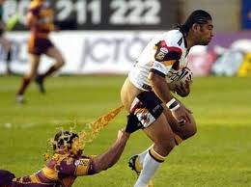Shit happens.

WORLD: The Ontario Securities Commission alleges that senior company officials of Sino-Forest, a China-based timber company listed in Canada, “appear to have misrepresented its revenues and exaggerated its timber holdings”. Shares of the group have lost almost three-quarters of their value since June and regulators ordered Allen Chan, Sino-Forest’s CEO, and four other senior executives to resign from their positions.

Sino-Forest executive.

CYBER WORLD:

-During November Walhallen Europadetektiv had the opportunity to meet and question Rikard Steiber, a graduate from Chalmer’s University of Technology in Göteborg and the highest ranking Swede of Google, at a late dinner venue about his view on cyber war, or more relevant, cyber defence strategy. Google was itself a rare exception when in January it claimed an intrusion alleging Chinese government links...The company, which has vested voting control in just three individuals, partially withdrew from China as a result. Jay Nancarrow from Google said: “We believe that more information sharing and dialogue around security is a positive trend for the industry”.

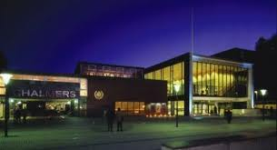Chalmer’s University of Technology

Washington has been reluctant to point the finger at rival powers, however, the US intelligence establishment brought into the public domain what many in government, the private sector and the media have been saying for years. An intelligence document blames the governments of the two rival powers, i e China and Russia, for campaigns to steal American technology, reflecting what analysts said was frustration at being unable to stop the spying through either diplomacy or technological defences. Massive cyber espionage by China and Russia poses “significant and growing threats” to American economic power and national security, US officials charge...



Israel clearly created the Stuxnet virus, which was uncovered in 2010 and apparently designed to spy on and disrupt Iran’s nuclear program, and the Chinese military is thought to have set up thousands (000’s) of units at technology companies and universities tasked with cyberattack and cyberdefence. Even if a majority of attacks clearly originates in China, Sr Col Geng Yansheng states with certainty that his country “is a victim of cyberattack”. The immense distrust between great powers gives little hope of global accord on security.



In any case it is vital for a company to map out what information it has, and its economic value, so it can make the right decisions about protecting it. You need to establish barriers, limit the number of people who have access to information – who is handling the data and why – maybe encrypting it, while sending data to third parties should be limited whenever possible. When using cloud computing providers, look at whether the server is co-located? Where does it reside? Is the server in your country? A good system should be like an onion, with layer upon layer of security, each one more impenetrable than the last. Diversify and backup continously....

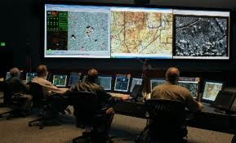

Please read our extensive report, “No One is Really and Completely Prepared for Cyber War”, due to be published in mid-April.

The simple solution is not always preferred, albeit the best solution is always simple.



WE WISH YOU A HAPPY AND PROSPEROUS NEW YEAR!

CE / December 2011

Walhallen Europadetektiv assumes no legal responsibility for whatever information our newsletter may contain.

