WALHALLEN EUROPADETEKTIV – PRIVATE DETECTIVE

COMMERCIAL – INDUSTRY - BUSINESS DETECTIVE

USA – BRAZIL – FRANCE – GERMANY – SWEDEN – UKRAINE – RUSSIA – CHINA

NEW YORK – DALLAS – SÃO PAOLO – PARIS – BERLIN – STOCKHOLM – KIEV – MOSCOW – BEIJING

CRIME SCENE l-12 / CAPITALISM INERTIA.

INTRODUCTION

Capitalism is like an energetic child who needs boundaries and discipline!

There is a heavy rain-fall when you leave your home walking to the bus station: should you stroll slowly or run? Most people can not tell, and not of the method suitable for application; as they can neither of what E=MC², as they often use, means. Any decent professor of physics will teach that extending, or prolonging, a case - a sequence - a scenario, in absurdum if necessary, will give an answer. So, if the heavy rain-fall continues, that is, will either a walking speed of 0,1 kilometer/hour – like a turtle, or 110 kilometer/hour – like a cheetah, make you the most wet? Suddenly, we know the answer.



A first year student of law will, or should, know what adequate causation means, including legal cause and effect, and that causation generally is not correlation. A ditto student of economics will, sooner or later, come across the paradigm of joint award laurates Modigliano and Miller, concerning debt/equity ratios – leverage – and whether, in theory, it affects investment decisions; as well as, hopefully, coming to the insight that calculating is not analyzing, being efficient is not necessarily being effective.

So, we got a grip, or “follow the remorseless logic”, of sciences; however, economics and law are bad cousins to natural science.

At a late dinner venue in early March in Göteborg this year with Anders Borg, finance minister of Sweden, Walhallen Europadetektiv had the opportunity to contemplate, ventilate and analyze various alternatives of judgement.

Economics is not a technique in search of problems, but a set of problems in need of solution. Problems are varied and the solutions will inevitably be eclectic. Pragmatic thinking requires not just deductive logic, but an understanding of the processes of belief formation, of anthropology, psychology and organisational behaviour; and meticulous observation of what people, business and governments do. Systems of economics are also, no doubt, reflexive, in the sense that beliefs about what will happen influence what does happen.

Many e g propose to reduce consumer spending in countries in Europe with trade deficits, and there are a great many, since each nation’s current account balance is the difference between its national saving and investment. But reduced consumer spending would just cause GDP to decline, unless there was a fall in the exchange rate to stimulate exports – something precluded within the eurozone.
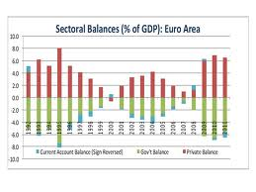Current Account Balance – in balance - always

Fundamental factors imply that the euro should eventually appreciate relative to the dollar, alas, concerns about the euro and the European economy more generally have caused the currency to decline relative to the dollar over the last few years.

Europe’s leading politicians have performed admirably. They have done their job by staying “cool” and trusting themselves. BEWARE THE EXPERTS WHO COME BEARING ADVICE....AND IN PARTICULAR ECONOMIC EXPERTS....

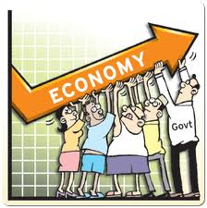

The study of financial markets revolves meanwhile around the “efficient market hypothesis” – that all available information is incorporated into market prices, so that these prices at all times reflect the best possible estimate of the underlying value of assets – and the “capital asset pricing model”. This latter notion asserts that what we see is the outcome of decisions made by a marketplace of rational players, acting on the belief in efficient markets. Albeit, due to the lack of transparency markets are unable to make proper assessments of risk and pricing and, worse, neither could systematic risks be measured.

So, how good-great-important-major is Mr Borg, elected the best finance minister in Europe by several newspapers, in and for Sweden-Europe? Instinctively and not illogically, we do bow, in these matters, to the verdict of Judge Time. “Ah, but is the hard job of real leadership – to make people confront unwelcome truths – measurable?”

So, what are unwelcome truths? That we devote, ought to devote, equal attention to business-industry as we do to the public sector – defence / schools / pensions / hospitals / immigration / etcetera. I question whether such rationality is the norm among the American and European peoples.

The business man is only tolerable so long as his gains can be held to bear some relation to what, roughly and in some sense, his activities have contributed to society. On that basis, no one can be surprised that the legitimacy of capitalism is currently in question.

So, who and what are then these capitalists: Europeans and Americans, unable to compete, turned into financial engineers, inventing and selling a multitude of opaque money-based products? Do we have a case of non distributo medii – undistributed middle: business people and entrepeneurs are capitalists; capitalists are greedy, selfish and morally bad; business people and entrepeneurs, the foundation people of civilization as we know it, are all greedy, selfish and morally bad?

But, who are these Germans-nordic people, with their work ethic, their competitive industrial sector and their success in exporting to America, Asia and the world? Are they a tiresome nag, forever blathering about fiscal probity, endlessly insisting on the value of industry and engineering prowess?

It is most favourable to let the Germans, and other good – but in essence and theory still bad – capitalists / entrepeneurs / industrialists, real men making real things, soil their hands with trade and industry while the rest of us live off the prosperity it brings. “You can always tell a German, but you can’t tell him much”; boring.

Let us talk instead about Greece, the country of Plato; not mentioning its debt but its history. Forget the [debt] torpedoes; full speed ahead. Sic transit gloria mundi – Let the glory and beauty of the world perish.

Gloria mundi

What is the moral of my journey; a journey of a private detective – private investigator specializing in deductive reasoning? That the difference between good and bad capitalists-industrialists-entrepeneurs, whatever descriptive word we choose, lies in the channels of greed – the degree to which the quest for profit is directed towards the creation of new wealth rather than the appropriation of wealth already created by other people. The market economy is a very, very different beast from crony capitalism.

EUROPE

BENELUX: The European Commission has fined four distinct transport cartels €169m. “The fact that such deliberate organised illegality can still take place today is shocking,” said Joaquín Almunia, the European Union’s competition commissioner. Competition officials broke the cartel after being approached with incriminating information by Deutsche Post – owner of DHL – which was later awarded immunity from fines. Groups fined include UPS, Kuehne & Nagel and Panalpina. Se non é vero – Even if it is not true, it is well conceived.



-The European Commission is taken to court by Deutsche Börse, trying to overturn its decision last month to block its [DB’s] tie-up with NYSE Euronext, in what would have been the world’s largest exchange deal ever. One lawyer – and there are many – said Börse’s move “sounds like pure optics and annoyance”.

-The ICC, the International Criminal Court in The Hague, has not concluded a single trial in its first 10 years. However, getting closer, Thomas Lubanga – who has been in ICC custody for six years – will receive his sentencing during the spring month of May. Mr Lubanga, a former militia leader in the Democratic republic of Congo, is accused of conscripting child soldiers during that country’s civil war a decade ago. Fighting for pro aris et focis – for home and stove? No.

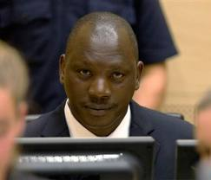Thomas Lubanga

CYPRUS: Elena Ambrosiadou - owner of the Maltese Falcon, the world’s largest yacht - has lost the first instance in the legal battle against her estranged husband, Martin Coward. Ms Ambrosiadou had tried to force him to pay back $120m he obtained from the trust that warehouse the couple’s fortune. Ms Ambrosiadou has also been running “large-scale” surveillance operations, targetting her former husband, which involved an Israel-trained agent who went “undercover”. Mirabilis scientae fundamenta.

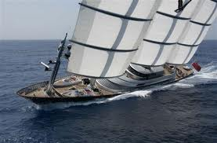Maltese Falcon

ENGLAND: Surveillance means security? A proposed legislation in the UK will enable police and other government bodies to monitor emails, Facebook, Skype etc. Without a warrant, information will be limited to “who, when and where”. An unholy alliance between internet companies – the experts and storage moguls in the digital age – and intelligence agencies might mean the real culprits will “go dark” as it is called, i e using internet cafés.

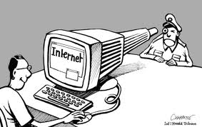Internet spying

-US regulators has imposed the highest fine ever, $100m, on a UK hedge fund manager. A US court set the penalty in February on Lewis Chester and his firm Pentagon Capital Management, for defrauding American mutual funds of tens of millions of dollars between 2000 and 2005. Judge Robert Sweet stated that Mr Chester and PMC “intentionally and egregiously” violated antifraud provisions of US securities laws. “Nothing is more hateful to wisdom than excessive cleverness”.

-Rupert Murdoch’s News Corporation are facing new allegations over its business practices after an Australian newspaper released over 15,000 emails concerning one of the group’s security subsidiaries. The emails, purportedly originated from the computer of Ray Adams, a former commander in the Metropolitan Police in London, who served as head of operational security for News Corporation in Europe from 1998 and 2004. If Mr Murdoch and News Corp are “fit and proper” to own a broadcasting licence is the question. Put more trust in nobility of character than in an oath.

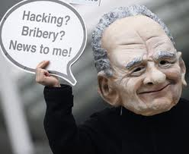Rupert Rupert!

-Coutts & Co, the private bank used by Queen Elizabeth II, was fined £8.85m for violating money laundering rules after it failed to conduct proper checks on almost three-quarters of clients that held politically sensitive positions. The issues were centred on Middle Eastern and eastern European clients. By settling early the bank qualified for a 30 per cent discount.

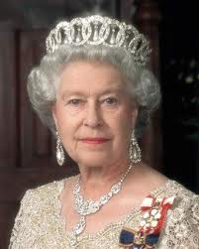Queen Elizabeth II

-With the introduction of the Bribery Act last year, Britain’s Serious Fraud Office – the anti-corruption authority - expect companies to face much higher fines as part of plans to introduce US-style plea bargains, known as deferred prosecution agreements. The US Department of Justice netted $2.3bn from 32 agreements during 2011. Fiat justitia, et pereat mundus – Let right be done, even if the world perishes.

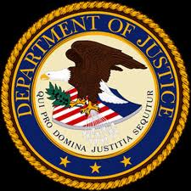DOJ

-Nicholas Kyprios, head of credit trading at Credit Suisse, has been fined £210.000 for disclosing confidential information about a forthcoming €2.5bn bond issue. The Financial Services Authority accused Mr Kyprios of “playing charades” with fund managers – “guess the group?” type-of-game.

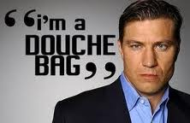Nicholas Kyprios

Almost simultaneously, Andrew Osborne, formerly of Bank of America Merrill Lynch, was fined £350.000 for tipping off US hedge fund investor David Einhorn to a 2009 rights issue by Punch Taverns, the UK pub chain. Suspicious trading ahead of deals remains a serious problem in both the UK and the US.

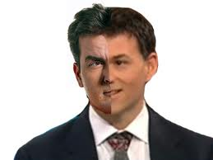David Einhorn

-As JP Morgan Chase, the US bank, had not ringfenced billions of dollars of client money, and industry tribunal has fined the UK arm of PwC, the auditor, £1.8m. The fine is the largest for a UK accountancy, albeit dwarfed by the £33m fine levied on JP Morgan Securities Limited by the Financial Services Authority. PwC admitted failings and had suggested – a brave gesture – a fine of £0.5m. The US arm of PwC was auditor to MF Global, which collapsed last year, leaving $1.2bn of customer funds missing. Mare Tenebrarum – Sea of Darkness.

-In the never ending legal saga between the two Russian business tycoons Boris Berezovsky and Roman Abramovich, which has so enthralled London’s legal community, there have been new stunningly murky deals laid bare. In this most extraordinary legal battle ever fought in the UK’s High Court, Mr Abramovich, who amongst other assets owns Chelsea Football Club, was painted as a “thoroughly dishonest and cynical witness”.

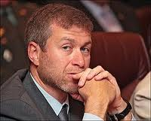Roman Abramovich – Vory v zakone.

The case centers on allegations that Mr Abramovich intimidated Mr Berezovsky into selling his oil and gas holdings. Mr Abramovich denies this and claims he paid Mr Berezovsky $2.3bn. Last month Lord Sumption told the court on behalf of Mr Abramovich that Mr Berezovsky was a man of ”vanity and self-obsession”, and had a “constant and palpable desire” to portray himself as the “central indispensable figure in every venture he has touched....Grave accusations!

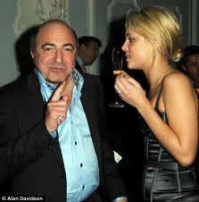Boris Berezovsky – Vory v zakone.

-The British police are not looking for supermen: what is wanted, it seems, is normally-sized people, something the Metropolitian police turns out to have a serious shortage of. A review has found three-quarters of the male officers overweight or obese. What that figure would be analyzing the doughnut-munching of New York’s finest, one can only guess? Ne humanus crede – Trust no human.

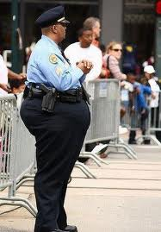Doughnut man

The police must be representative of those they serve – as most police forces around the world would adhere to – and accordingly the Swedish police force has starkly lowered their required language standards, to mirror the new multi-cultural society....making a virtue out of a necessity.

FRANCE: Dominique Strauss-Kahn – yes, the same as always in sex affairs – has been placed under investigation by a French court for alleged involvement in a prostitution ring. His lawyers claim he has been unfairly targeted because of his “libertine” lifestyle, and predicted the case would collapse. The charges carry potential combined jail sentences of up to 20 years. Eight other men, not able to pay the bail of individually €100,000, are already under arrest.

DSK insisted that he did not know that the women he encountered at sex parties were prostitutes. His lawyer stated: “At these kinds of parties, you are not always clothed. I challenge you to tell the difference between a naked prostitute and a naked worldly woman”. Ce n’est pas convenable.

DSK with wife.

-Areva of France and Siemens of Germany are close to settling their fight over their ill-fated nuclear power joint venture; a joint venture also under a 20-month European Commission investigation into potentially illegal “non-compete” clauses in the tie-up, which ended acrimoniously in 2009.

-The Autorité de la Concurrence – the French competition regulator – has fined a 14-strong group of French and German flour millers €242m. The information of regular meetings – where decisions were taken to limiting access to each other’s markets between 2002 and 2009 – came from a German whistleblower, as also in the case of a recent transport cartel. Achtung, achtung!

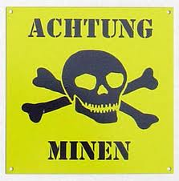

GERMANY: Microsoft, the US colossal software group, is moving its European distribution centre from Germany to the Netherlands so that gaming consoles and Windows 7 software cannot be seized by authorities, if it loses a patent lawsuit this month. It is the first time a company has chosen to move operations out of Germany to avoid its strict patent laws. Status quo ante – The happy state before.

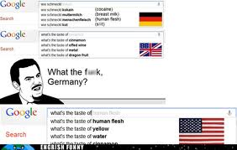

-After bribing government officials in Montenegro and Macedonia, Deutsche Telekom and its Hungarian subsidiary Magyar Telekom, has agreed to pay US authorities $96.2m. The US Department of Justice agreed not to criminally prosecute Deutsche Telekom and Magyar with corruption under the US Foreign Corrupt Practices Act for two years, during which time the companies must strengthen internal controls and refrain from breaking US law. Der Preis muss ausgerechnet werden!!!

GREECE: Following a sting operation by the SDOE financial police, the Greek government has suspended more than 100 civil servants involved in awarding investment grants, following the arrest of two officials for taking bribes. A special European Union taskforce has been created to patch-improve Greece’s notoriously leaky tax collection system.

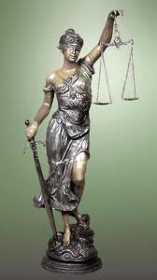Greek justice

-An out-of-court settlement has been reached between Greece and Siemens; the latter to pay compensation for alleged bribery of local politicians and state officials amounting to €170m, as well as make a €100m investment to ensure its Greek subsidiary, which employs 600 people, continue its operation. Hardly a defeated people’s natural slavery.

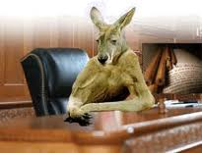Kangaroo court

HUNGARY: Europe’s main human rights body states that “Hungary’s media watchdog lacks transparency, has excessive powers and is staffed on a political rather than a professional basis”. The preliminary report by the Council of Europe adds to the growing criticism of legislation passed by the centre-right government of Victor Orbán, prime minister, since his election two years ago. The analysis says Hungary’s media law erodes the protection of journalists’ sources. A fly in any journalist’s ointment.



ICELAND: Former prime minister of Iceland, Geir Haarde, will face trial during April for his role in the Icelandic financial crisis. Mr Haarder, who ran the country from 2006 to 2009, faces two years in jail if found guilty next month. He denies the charges. The crisis led to a 10 per cent decline in gross domestic product and a sevenfold increase in unemployment. One man’s Utopia is another’s Dystopia.

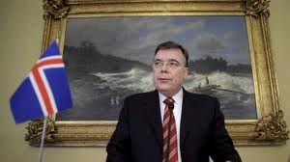Geir Haarde

IRELAND: In the longest running corruption inquiry in Irish history, Ireland’s former prime minister, Bertie Ahern, has failed to “truthfully account” for IR£65,000 received in secret payments, according to the final corruption report. The report found corruption was “endemic and systematic” in political life from the late 1980s to the late 1990s. It concluded that “public apathy” towards corruption enabled it to continue. Ironically, the tribunal of inquiry was established by Mr Ahern when he was prime minister in 1997 to investigate corruption. O sancta simplicitas.

Bertie with Maestro

ITALY: Operation Bad Metal – an anti-mafia operation – has seen the arrest of 47 people and the seizure of over €1bn of assets. The operation involved authorities in Switzerland, Belgium and Luxembourg according to tax prosecutors. Prosecutors also confirmed the horrible – 16 tax judges in Naples were included in the 47, arrested on suspicion of being involved in a “vast web of corruption” regarding “illicit trade of court verdicts” inflicting “incalculable damage” on the state. Sub rosa metal, to say the least.

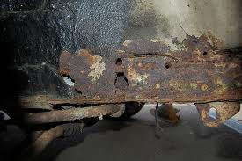Bad metal

-Silvio Berlusconi, former pm, states that his party is the liberal soul of the country. Mr Berlusconi has proposed a law that would sharply curb the powers of the judiciary to use wiretaps, and the media to publish leaked transcripts.

“It is barbaric to tap and more than barbaric to publish”, says the former leader, whose private conversations have been splashed across the media. He says he no longer uses a mobile phone, claiming he discovered he was being tapped by seven different sources. Conatus sese conservandi – The striving for self preservation.

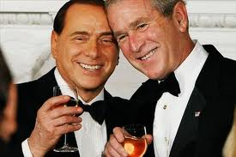Two “Maestros”

RUSSIA: Alexei Kozlov, a Russian businessman, married to Olga Romanova – a well-known Moscow journalist – and one of the faces of the political protest movement the passing winter, has been given a five-year sentence for money laundering and fraud. This sentence was disclosed just days after his wife spoke at two Moscow opposition rallies. The verdict against Mr Kozlov came the same day that the same Moscow court gave Sergei Udaltsov - another Russian dissident - 10 days in jail for attempting to lead an unsanctioned march.

Ms Romanova warned that the court delivering the fresh sentence was making a “huge mistake”, and that her husband, who had once been just a “banal businessman”, would become politically active following his release.....Maybe a disguised blessing.

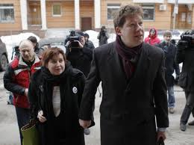Alexei Kozlov

-Vladimir Putin, Russia’s newly re-elected president, said in an article that private companies had proved unwilling to take on the risks in fostering innovation. Mr Putin cited China and South Korea as successful role models, and defended the state corporations created under his rule. He stated: “Only the state was in a position to ensure financing for the high-risk innovations needed to reduce Russia’s dependence on commodity prices.”

A think-tank viewed the opinion that the government is corrupt and this is a return to the chaebols of South Korea. Mr Putin admitted “systemic corruption” was hindering private business, saying the entire court and law enforcement system had to be changed, while all commercial disputes had to be transferred from criminal to commercial courts to break collusion between prosecutors and judges. Why hire a lawyer when you can buy a judge.

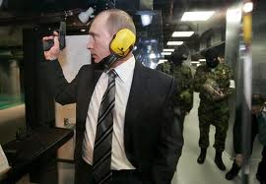Siloviki – V Putin.

SPAIN: Iberia, the formerly state-owned Spanish airline that last year merged with British Airways, announced in March that it was suing pilot and cabin crew unions in Spain’s high court, asking for planned strikes to be declared illegal and seeking damages for previous industrial actions.



-The well-known Spanish judge Baltasar Garzón, famous for his investigations into international human rights abuses, has been found guilty of ordering illegal wiretaps during a case involving corruption within the ruling Popular party.

A court ruled that Mr Garzón had broken the law seriously when ordering prison wiretaps of inmates and their lawyers in 2009. Mr Garzón shot to international prominence for having Augusto Pinochet, the Chilean dictator, arrested in London for alleged human rights crimes in an ultimately unsuccessful attempt to extradite him for trial in Spain. Maybe Mr Garzón will read about the ultimate vanity in fighting windmills, like Don Quijote and Sancho Panza in the literature of Cervantes.... El vencido – vencido y el vencedor perdido / The defeated defeated – and the victor lost.

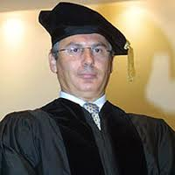Baltasar Garzón

SWEDEN: Sten Tolgfors, the defence minister of Sweden, has resigned over the leaked plan to build an arms factory in Saudi Arabia. Carl Bildt, Swedish foreign minister, argued in parliament over the definition of what constitutes a factory – reading out from Svenska Akademins Ordlista – and argued the planned buildings constituted something else. Criminal investigations were started into whether a shell company was set up to avoid any direkt links between a Swedish military agency and the Saudi regime, and whether the document leak was a breach of national security. A daily practice of courage.

Sten Tolgfors

-The two Polish nationals detained by Swedish police under suspicion of murdering an elderly couple, and stealing their 150 kg safe, some 60 kms north of Göteborg, are still under pending prosecution. They were arrested outside Gdansk in November, and later extradited to Sweden. The prosecution in court has been extended a sixth time, a record, alas, we are told a formal prosecution will follow shortly.



SWITZERLAND: Michael Lauber, Switzerland’s federal attorney has issued arrest warrants against tax officials from the German state North Rhine-Westphalia. These [Deusche Steuerbeamten] have paid, illegally, for bank account records belonging to German citizens with accounts in Switzerland.
Qui bono – Die Ruckwertigen Dienste?

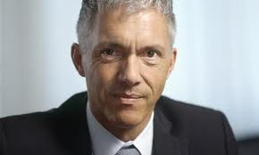Michael Lauber

UKRAINE: Prosecutors in the country are probing whether Yulia Tymoshenko was involved in ordering the 1990s contract killing of lawmaker and businessman Yevhen Shcherban. Mr Shcherban was shot along with his wife and two associates at Donetsk airport in 1996. New formal accusations of corporate tax evasion has also been brought against Ms Tymoshenko. Her lawyer talks of unfounded propaganda and the link to the murder of Mr Shchernan “grotesque”.The state prosecutor asks, after severe EU criticism: “What is your view in the west, of political persecution? Does this mean that the leader of the opposition can’t be prosecuted, even for murder? That such people are above the law?” A relevant question.

Ms Tymoshenko is still confirmed ill, in pain and not receiving proper medical care, according to her doctor. She was sentenced last year to seven years in jail on corruption charges, and the US and European Union have repeatedly expressed concern that her trial and sentencing were politically motivated. One German doctor was quoted on Radio Free Europe/Radio Liberty saying she was “seriously ill”. Doubt everything.

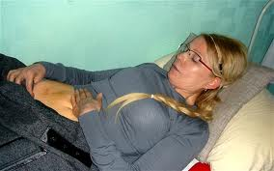Ms Tymoshenko

THE AMERICAS

BRAZIL: Chevron, the US oil giant, has seen 17 of its executives in Brazil losing their passports. A federal judge in Rio de Janeiro has granted a request from the prosecutor’s office to withhold the passports of the executives, who include George Buck, the head of Chevron in the country [Brazil]. The legal move comes after a fresh incidence of oil seepage from the sea bed close to one of Chevron’s facilities.



Chevron stated the following: “Most of the oil coming from the seep is now being captured by specially built containment devices. Additional containment devices will be installed as needed.” Brazil’s former president, Lula da Silva, once famously said: “Not only the blue-eyed can invent and manage things in this world.” Maybe the pawning of passports is a reaction to this attitude?

Walhallen’s operatives never leave Europe or America without two valid passports in the briefcase. It is your civic and paramount right, so please check with your local police....”A man with two houses loses his mind, a man with two women loses his soul”, albeit “a man with two passports feels safe”.

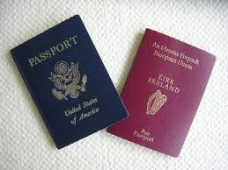

ECUADOR: Rafael Correa, Ecuador’s leftist president, has won a libel court case aginst three executives of the newspaper El Universo. The three, two awaited the verdict in Miami and one is seeking asylum in Panama, reiterated: “Nothing will do a better job of keeping the media in check than this sentencing. This is going to shut everyone up, because no one wants to face three years in prison and a $48m fine for publishing an opinion.”

Mr Correa, who himself appeared for the extended hearings in court, and who had been called “The Dictator” in El Universo, stated briefly: “Freedom belongs to everyone, not just those who can afford to buy a printing press. This has been a struggle for freedom of expression.” Plus ultra.

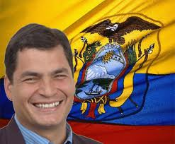Rafael Correa

USA: KPMG, the leading accountancy firm – if such one exist, has paid the US tax authorities $548m
in fines over illegal tax shelters created and sold during 2005. Despite overwhelming evidence, the firm escaped criminal prosecution.

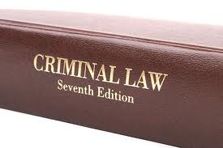Criminal prosecution

-Up to 1.5m card numbers in North America may have been stolen in a security breach at Global Payments, a processor of credit and debit card transactions involving brands such as Visa and MasterCard. “Based on the forensic analysis to date, network monitoring and additional security measures, the company believes that this incident is contained.”

-Americans might individually be required to purchase sick-health insurance, by 2013 and onwards, or pay a penalty. Barack Obama has signed the Affordable Care Act into law, but the Supreme Court will not rule on the validity of the law until June. Some arguments by justices of the court exposed a willingness to strike down the law.

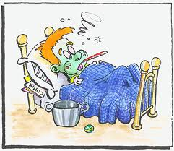Definitely sick

-Avon, under an unsolicited $10bn cash offer from Coty, the privately owned US fragrance group, is seeking to stay independent while searching for a new chief executive and grappling with financial and legal troubles. It [Avon] is facing an investigation into bribery allegations involving its Chinese business, as well as a regulatory probe into its contacts with financial analysts in 2010 and 2011.

Moreover, Avon has spent more than $150m on an internal investigation of alleged corruption among sales representatives in Latin America. The penalties for misconduct in America, south and north, as well as in Asia, could be steep indeed.



-Louis Freeh, a former director of the Federal Bureau of Investigation, has been commissioned by Wynn Resorts, a Las Vegas casino and hotels group, to prepare a report on suspicious corruption involving Kazuo Okada. Mr Okada, a long-time partner of Steve Wynn, Wynn Resorts’ CEO, is accused of bribery contemplating building a casino group in Manila Bay, the Philippines. A court in Nevada has decided Mr Okada should, by forced redemption, return his $2.77bn stake in Wynn resorts to Mr Wynn....Robbing Peter to pay Paul, as the saying goes????

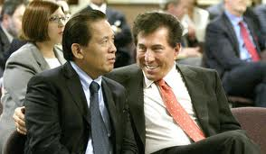Okada and Wynn before.

-Allan Stanford, the Texan banker, has at last been convicted of stealing roughly $7bn in his Ponzi scheme that lasted for a decade. After the six-week trial in Houston, the jury voted to convict Mr Stanford guilty on 13 of 14 counts. He will be sentenced on June 14th, and can expect roughly a decade+ in prison. Pues, yo soy el sin ventura Stanford.

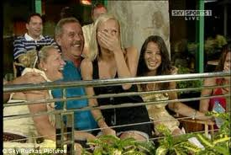Stanford in happier times.

CANADA: Pierre Duhaime, chief executive of SNC-Lavalin, a Canadian and construction company, has been relieved of his duties after permitted colleagues to make $33.5m of suspect payments despite the fact that the chief financial officer of the company had refused to sign off on the transaction. SNC accepted that authorities in Canada “could bring sanctions in due course”.

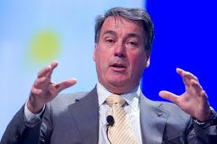Pierre Duhaime

ASIA

CHINA: Sino Forest, which had a market capitalisation of $6bn at the start of last year, plagued by accusations of overstating its assets, intends to file for bankruptcy protection. It will also sue research group Muddy Waters for $4bn in damages over fraud claims that proceded its failure. Muddy Waters has published a report last year that accused the Chinese forestry company of overstating its timber assets, simultaneously challenging the role played by Chinese third parties known as “authorised intermediaries”.

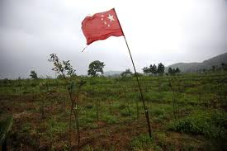Sino forest

-Raymond and Thomas Kwok, co-chairmen of Sun Hung Kai Properties, have been arrested in connection with a corruption investigation.The group, Asia’s largest property developer by market capitalisation, closed 13 per cent down, cutting the company’s market value by US$4.9bn in 24 hours.

The two brothers, aged 59 and 60 respectively, are evangelical Christians and extremely devoted to their mother, but their image has been grossly shattered by news of their arrests in connection with the investigation. Sun Hung Kai was founded by the Kwok brothers’ father in 1963, and the family still control a 42 per cent stake in the company, worth $18.3bn.

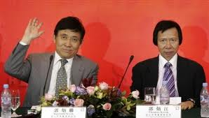Kwok frères

-IP (Intellectual Property) lawsuits have risen by 38 per cent last year in China, to an astounding 66.700. The stakes are high: Apple is fighting a trademark suit in China that threatens to shut down mainland distribution of iPads; Hermès recently failed to stop a Chinese company selling clothes under its trademark, and Pfizer lost a trademark case against a Chinese company that sells electronics under the brand Little Viagra. Many feel it is fine to steal IP from foreign companies – just not from their neighbours.

Big Viagra

-Sina Corp and Tencent, Chinese companies with operations equivalent to Twitter, have barred users from commenting on others’ posts. The government has announced that six people had been detained
and 16 websites closed for spreading rumours about a military coup in Beijing. A further 1,065 people have been arrested so far during 2012, and more than 208,000 messages deleted. Beijing police told state media they had issued warnings to 3,177 websites across the country, and that they had punished 70 internet companies, including through forced closures.

-An expatriate Englishman suspiciously dead in China. Many of Neil Heywood’s friends were sceptical when cause of death was confirmed as “excessive alcohol consumption”, and that the body had been cremated within 48 hours without a full autopsy. Mr Heywood was found last November in his hotel room in southwest China, and acquaintances described described Heywood as “very well-mannered”, and people who knew him say he was not a heavy drinker.

The powererful police chief, Wang Lijun, of Chongqing, a region with 32m inhabitants, on February 6th arrived at the US consulate in the megacity of Chengdu and requested political asylum, claiming he feared for his life. Mr Wang claimed to have evidence that Heywood was in fact poisened on orders of Bo Xilai, Chongqing Communist party secretary – Mr Wang’s former boss, and one of the country’s most powerful politicians.

Gu Kailai, the wife of Bo Xilai, arrested in March, is said to have had intense business dealings with Heywood, and Mr Wang believed his own life might also be in jeopardy after falling out with Mr Bo. All this has triggered the dismissal of Mr Bo as Chongqing party secretary on March 14th , in what has become the most significant political event in China since the 1989 Tianmen Square massacre.

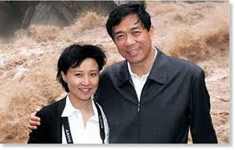Bo and Gu

British diplomats have requested that China launch a fresh investigation into Heywood’s suspicious death. Many business people in Beijing describe Heywood as a “foreign consigliere” to the Bo family. Others say they always suspected he was working for the British intelligence services, adding a new level of intrigue to his death. The British do not comment on intelligence matters......

Many details of Heywood’s life remain unknown, although after graduation from Warwick university in 1992 he moved, more or less, permanently to Beijing, China. After meeting his Chinese wife, Puli, with whom he had two children, he also befriended Mr Bo, then mayor of Dalian, and his family.

Mr Bo himself, son of Bo Yibo, a revolutionary hero known as one of the “eight immortal” Communist party elders who ran the country from behind the scenes in the 1980s and 1990s. The Bos, rightly or wrongly, regarded themselves as part of China’s “true aristrocracy” – the “red-blooded” rightful heirs to power – and they seem to have an inclination with European aristrocatic traditions.

Heywood, a Beijing resident at the time of his death, often travelled to Chongqing on business after Mr Bo moved there in 2007. His official job was as a consultant to the Aston Martin dealership in Beijing. Whether Heywood was just a well-paid consultant who provided harmless business advice to western companies or whether he had a more formal role in Britain’s intelligence network will probably never be known.

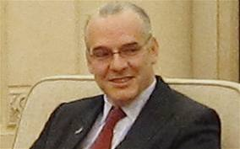Heywood

As always, good advice is free and plentiful, albeit coming too close to foreign power-brokers is a dangerous game, in China as well as in many developing countries. Cometh the hour, cometh the man.

-Since China’s attitude towards lawyers has always been conflicted, it has now ordered lawyers to swear allegiance to the Communist party, tightening its grip on legal activities. Beijing has already detained scores of lawyers since online calls early last year for an Arab spring-style revolution. New lawyers and those renewing their licences to practise would have to take an oath of loyalty.

Chinese lawyer

They will be required to say: “We promise to faithfully carry out the sacred mission of legal work under socialism with Chinese characteristics, to be loyal to the motherland, to be loyal to the people, [and] to support the leadership of the Chinese Communist party”.

-Wu Yidian Eden, a Singaporean citizen employed by UK bank Standard Chartered, has been detained by Chinese police as part of an investigation into a wealthy client who allegedly stole money from a state-owned bank. The detention highlights the risks for foreign bankers stationed in China. A study by the China Reform Foundation found in 2010 that Chinese households hide as much as Rmb9.3tn in income, much of it “illegal or quasi-illegal”.

INDIA: Vodafone, the British-listed global mobile phone group, won its taxation case in India’s supreme court. The capital gains tax, preposterously levied as we wrote in Crime Scene IV-11, amounted to $2.9bn and arouse from transactions completely outside India itself, at a parental company level. It [India] will have to return the $496m asked as a security deposit with 4 per cent interest.



A previous judgement in the Mumbai high court in September 2010 found against Vodafone, leading many who followed the case to predict a repeat judgement this time. “This decision will provide relief to global investors thinking of coming to India, and also shows definitely that the Indian judiciary remains independent of its political system”, says some... At Walhallen we remain sceptical, and bear in mind the enormous opportunity costs in a process as this one.

The East India Company in Britain was founded in the year 1600, a date many consider the commencement of modern times due to this occassion; not when Johannes Gutenberg invented the printing press, in 1440; not when Columbus discovered America in 1492, not when Martin Luther published his 95 theses in 1517 .....

By the early 1800’s the East India Company had a standing army of 200.000 extremely modern equipped men, with its main raison d’être being to tax Indians, rather than exploiting its lapsed monopoly of trading with India/south Asia. The ridiculous tax claim by India’s tax authority might then have been a tit-for-tat centuries later? Maybe, just in time-just enough?

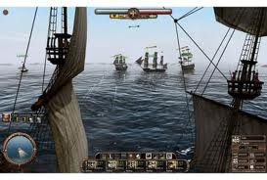The East India Co.

JAPAN: The never ending saga of Olympus, and its fraudulent accounting, has put some seven men in custody/arrest. Four other men working for firms that advised Olympus in acquisitions connected to the alleged fraud are also behind bars. Michael Woodford, the Briton who exposed the fraud, says: “After going to hell and back, this is a day to remember”. Mr Woodford is suing Olympus over his dismissal and the arrested men face up to 10 years in prison.



PAKISTAN: The US has offerred a $10m bounty for the information leading to the arrest of Haifiz Saeed, one of Pakistan’s most notorious militants. Mr Saeed appeared before journalists in March – claiming the bounty for himself. Pakistan’s foreign ministry said the country needed “concrete evidence” of terrorism to proceed legally.

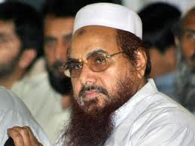Haifiz Saeed

-Bin Laden’s three widows and two daughters have been sentenced to 45 days in jail, a local court finding them guilty of staying in the country illegally. Each member of his family was also fined $110 each, and will eventually be deported to their home countries throughout the Middle East.

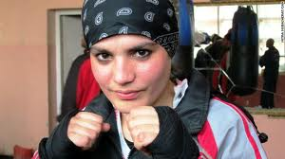Fighting widow

VIETNAM: In Vietnam, nine executives of Vinashin, a debt-ridden state-owned shipbuilder, went on trial yesterday. At the court in Haiphong, they were charged by the judge with deliberately violating state regulations on economic management leading to losses of more than $43m. The company nearly collapsed in 2010 after amassing more than $4bn of debt having invested in non-core areas from motorbike manufacturing to power plants. Pham Thanh Binh, former chairman, told the court that the losses were “not my fault personally” and that they were the results of “objective conditions”.

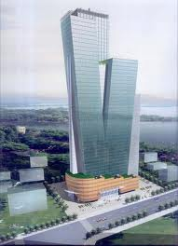HQ Vinashin

CYBERWORLD
The founder and chief executive of Megaupload.com, German-born Kim Dotcom, formerly known as Kim Schmitz, has been arrested in Auckland, New Zealand. Megaupload.com, the file-sharing site that the US authorities claim distributed half a billion dollars’ worth of illegal content, has also been closed. Mr Dotcom is under pending extradition to the US, alongside his alleged co-conspirators.

Kim Dotcom

-Huawei, the Chinese group – and the world’s second largest telecom equipment supplier after Ericsson of Sweden – with a diffuse ownership structure, has been barred from Australia’s A$42bn tender to build a national broadband network. The Australian government is concerned about alleged links to the Chinese military – perhaps allowing Beijing to eavesdrop on commercial and military secrets.

Huawei remains evasive about its ownership structure at a time when cyber attacks on western databases are rising. Its founder is a former member of the People’s Liberation Army and its chairman has been linked to the security services – which monitor everything from emails to texts on China’s network.



John Suffolk, the former chief information officer for the UK government, has been hired by Huawei as a cybersecurity official, trying to reassure customers who are concerned that it has links to the Chinese military. In 2009 Huawei hired Matt Bross, the former chief technology officer at British Telecom, as its CTO (chief technology officer).

Cyber crime and espionage originating in China and Russia are overtaking terrorism as a major security concern in developed countries. China has steadfastly refused to accept that it had a case to answer on the cyber attacks, and so its companies are made suspect.

Cyber spy

-The UK education secretary, Michael Gove, refuses to comply with the Freedom of Information Act, in effect opposing David Cameron, prime minister, who wants the coalition to be the “most open and transparent government government in the world”. Mr Gove though, conducted official business using a private email address registered in his wife’s name, and now denies security services access to the account.

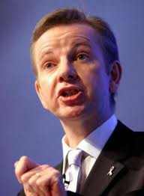Minister Gove

-US financial regulators will try to force companies to disclose their cyber vulnerabilities despite their huge potential financial and reputational harm. Collecting precise data on cyber attacks is difficult because governments and companies are reticent to admit that they have been compromised.

Robert Lentz, former deputy US assistant secretaryof defence for cyber, identity and information assurance, says that defence companies’ access to sensitive contracts gives them a vaunted position in a market that is growing in the public and private sector. “Defence ministries are the pacesetters to implement the visions and showcase capabilities that work,” he says. Some regard not finishing almost a mark of success.

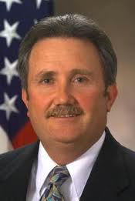Robert Lentz

-Verizon, the US communications company, has found that 174m records were stolen through hacking, viruses and other electronic untrusions in 2011. This is the second-highest since its Data Breach Investigations Report began being published in 2004. More than half of electronic records stolen last year were by “hacktivists” rather than traditional cybercriminals.

DESPITE ALL THIS NEGATIVE REPORTING, THE TRUTH IS THAT THE WORLD IS - AND PROMISES TO BE – A FAR BETTER AND SAFER PLACE FOR MANY MORE PEOPLE THAN IT WAS 50 OR 100 YEARS AGO.

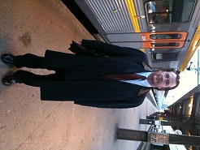
Mission Accomplished - Visiting “Moder Svea”. You won’t and shan’t recognize Walhallen’s operatives.

CLAES EKMAN
CE / August 2012

PS: Enroute to a dinner meeting hosted by AB Volvo’s new CEO, Olof Persson, early this summer, where I personally urged him [Mr Persson] to maintain the last pure Swedish vehicle manufacturer in native/domestic hands (Volvo Cars was first sold to Ford, then to Geely of China – Hägglunds military vehicle unit has been sold to BAE – Scania is owned to 72% by VW after a misguided proposed merger with AB Volvo, annulled by the EU commission – SAAB Automobile was sold to GM, then bust under the leadership of Dutchmen), I asked my driver to stop and observe the first ever security apparatus/alarm installed/mounted by me/us. Hey and behold, it still looks good, and is operational, after more than 30 years, installed in 1981, on one of Gothenburg’s finest houses. “Quality is free.” The owner later had us install one identical at his personal mansion.



By the way, Mr Persson promised me to do his utmost of keeping the Volvo Group a Swedish affair, “but not for eternity”. Overall, he seems to be the perfect guy to have Scandinavia’s most important management position.

AB Volvo’s new chairman, Carl-Henrik Svanberg, though, is another “kettle of fish”. Having been forced to take him to the Court of Stockholm in a case, he knew nothing, had seen nothing, although at last paying up amongst a great deal of hushaby. He may be talking about “the little people” in southern United States, the scout movement and cancer amongst his siblings; breaking obvious contracts with Russian oilmen and Swedish young ambitious business men is something else.

I don’t call him a cheat, a liar or an adulterer; neither a business eagle, a commercial wolf or an industrial tiger, albeit and alas, he’s simply not up to the job, nor to be trusted having it, in my humble opinion. His “golden rules” will turn to basic metal in due course, and get us all up in the morning, with sweeping Swedish job losses as a consequence.

Humans believe what they want to – Homines libenter quod volunt credunt. Always think about it, never talk about it.

Walhallen Europadetektiv AB assumes no legal responsibility for whatever information our newsletter may contain.

